##### Use Case-A Diagram

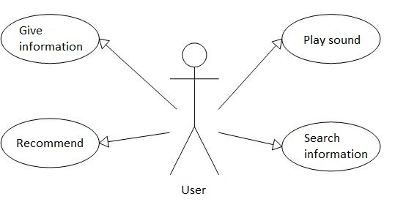

###### Use Case : Give information

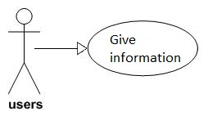

|  |  |  |
| --- | --- | --- |
| Use Case Name | Give information | |
| Actors | Users | |
| Description | Provide the detail Ho Chi Chi Minh city tourist information | |
| Requirement | Fields/Attributes must have validations on it | |
| Pre-conditions | Choose this function | |
| Post-conditions | Sound will be play | |
| Basic Flow | *Actor Actions:*  *1. Click “Information” button* | *System Response:*  *2. Display some famous location* |
| Exception Flow | N/A | |

###### Use Case 2: Play sound of Vietnamese communication sentences

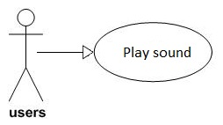

|  |  |  |
| --- | --- | --- |
| Use Case Name | Play sound | |
| Actors | User | |
| Description | Play sound of Vietnamese communication sentences from English sentences | |
| Requirement | Fields/Attributes must have validations on it | |
| Pre-conditions | Choose one sentence | |
| Post-conditions | Information will be display | |
| Basic Flow | *Actor Actions:*  *1. Choose “Read” button*  *3. Choose one place*  *5. Choose one sentence* | *System Response:*  *2. Display some place*  *4. Display some sentences*  *6. Play this sound* |
| Exception Flow | N/A | |

###### Use Case 3: Search information and sentences by keyword

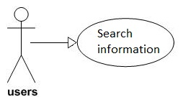

|  |  |  |
| --- | --- | --- |
| Use Case Name | Search information | |
| Actors | User | |
| Description | Search information about many function this software | |
| Requirement | Fields/Attributes must have validations on it | |
| Pre-conditions | Choose this function | |
| Post-conditions | Result will be display | |
| Basic Flow | *Actor Actions:*  *1. Choose “Search” button*  *3. Enter text*  *5. Choose “->” button* | *System Response:*  *2. Display textbox*  *4. Display some suggestions*  *6. Display list results* |
| Exception Flow | Can’t find any information. Display will be show “No result” | |

###### Use Case 4: Recommend these topics related which user reading

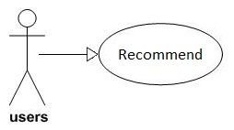

|  |  |  |
| --- | --- | --- |
| Use Case Name | Recommend | |
| Actors | User | |
| Description | Shows these topics have relationship with it by a recommendation engine. | |
| Requirement | Fields/Attributes must have validations on it | |
| Pre-conditions | Choose this function | |
| Post-conditions | Information will be display | |
| Basic Flow | *Actor Actions:*  *1. Choose “Recommend” button* | *System Response:*  *2. Display result* |
| Exception Flow | Display “No result” if can’t find any information | |